Practical Session: using MAIHDA to look at intersectionality in subjective health
To start with, open RStudio.
The data (as well as slides from the lecture) can be found at this weblink: tiny.cc/MAIHDA23. I would recommend downloading these files into a folder on your computer, and then creating a project pointing at that folder. To do this, click on File – New Project, and select the Existing Directory as the folder with the data in it. Equivalently, make the file your working directory.
Next, install and load a number of packages that we will be using during this session:
install.packages("tidyverse", "lme4", "sjPlot", "merTools", "reshape2")
library(tidyverse)
library(lme4)
library(sjPlot)
library(merTools)
library(reshape2)

This session will use data from the European Social Survey – a cross-national survey, which I took directly from here: https://www.europeansocialsurvey.org/data/. The survey is repeated year-on-year, but we will use just one wave – wave 10 - for simplicity. There is a codebook, which might help to make sense of the variables we are using.
The outcome variable is “health” a measure of self-rated health, on a scale from 1 to 5, where 1 means very good health and 5 very bad. Whilst it might be better to use an ordinal logit model for such an outcome, here we’ll just act as if this is a continuous, approximately Normally distributed variable (again, for simplicity).
The variables we are going to use to define out intersections are as follows:
- Age (agea) – we will categorise this into 4 groups
- Ethnic origin (anctry1) – this contains many many different national (and subnational) identities, and we have to categorise these. Given the small size of the groups, we will classify these into 2 groups, European and Non-European (whilst recognising the issues in doing so!)
- Education (edulvlb) – again we will classify this into 3 groups: Primary education and less, Secondary education, and at least some University-level education.
- Gender (gndr) – in this dataset there are only two categories measured: Male and Female.
This will give us a total of 4*2*3*2 = 48 strata.
So, let’s load the dataset, which should be in your project folder.
ESS10 <- read.csv("ESS10.csv")
We now want to start recoding our variables. Note that there is a code file in the project folder, so this will mean you won’t need to type this recoding code out.
In each case, I am first recoding any missing codes to be “NA”, which is what R understands as missing. Second, I’m recoding the data into groups, using the cut function. I’m then renaming the levels (or categories) of that variable, using the levels function.
First, the ethnic origin variable, called anctry1. This is a categorical variable with each observation containing 5 numbers, where the first number is the largest spatial scale (eg, Europe) and the last number is the smallest (subnational). Here, we could recode based on that largest spatial scale, having first recoded the missing values (numbers over 100000) to be missing.
ESS10$anctry1 <- replace(ESS10$anctry1, ESS10$anctry1 > 99999, NA)
ESS10$ethgrp <- cut(ESS10$anctry1, breaks= c(0,19999,29999,39999,49999,59999,69999,79999, 89999))
levels(ESS10$ethgrp) <- c("Euro", "Arab", "SSAfrica", "SAsia", "EAsia", "Latin", "Carib", "NAmAus")

table(ESS10$ethgrp)

From the table of these categories, we can see that there is actually a very small number of people that are non-European, with some groups containing only 10 or so observations. If we attempt to cut these up further, by dividing them by the other intersectional variables, we’ll end up with many groups with very few (or even no) observations, which will make our analysis difficult to interpret with regard to those categories. As such, we might instead decide to divide these even more crudely, into 2 groups

ESS10$eth2 <- cut(ESS10$anctry1, breaks= c(0,19999, 89999))
levels(ESS10$eth2) <- c("Euro", "NonEuro")
table(ESS10$eth2)

Whether this is appropriate will depend on the theory around what ethnic differences we might expect, and the research questions that we want to answer. If we are particularly interested in the difference between, say Sub-Saharan African and Arabic groups, this grouping would not allow us to answer that question. If we were interested in the difference between, say, Bangladeshi and Pakistani groups, even the 8-group division above would be inappropriate. Again, we must make a judgement based on the questions we want to answer, theory around the differences between ethnicities that we might expect for a given outcome variable, and what is possible with the data at hand.

Let’s do the same with our other variables, first gender (gndr).

ESS10$gndr <- replace(ESS10$gndr, ESS10$gndr > 3, NA)
ESS10$gndr <- as.factor(ESS10$gndr)
levels(ESS10$gndr) <- c("Male", "Female")

Then Education (edulvlb):

ESS10$edulvlb <- replace(ESS10$edulvlb, ESS10$edulvlb > 5000, NA)
ESS10$educ3 <- cut(ESS10$edulvlb, breaks= c(-1,199,499,801))
levels(ESS10$educ3) <- c("Primary", "Secondary", "Degree")
table(ESS10$educ3)

Then age (agea)

ESS10$agea <- replace(ESS10$agea, ESS10$agea > 200, NA)
ESS10$agecat <- cut(ESS10$agea, breaks= c(0,25,45,65,150))
levels(ESS10$agecat) <- c("Under25", "25to45", "45to65", "over65")
table(ESS10$agecat)

It’s now sensible to remove all the other variables that we aren’t going to use, to keep our dataframe simple. We will also remove any missing values at this point too (given there are only a few missing values in this instance, we will just listwise delete them).

ESSc <- ESS10[c("health", "eth2", "gndr", "educ3", "agecat")]
ESSc <- na.omit(ESSc)

We’re now ready to generate our strata variable. We can do this using the “paste” function, which will just take the level labels of our variables and mush them together (separated by semi-colons as stated in the code):

ESSc$strata <- paste(ESSc$eth2,ESSc$gndr,ESSc$educ3,ESSc$agecat, sep="_")
table(ESSc$strata)

We can see a count of all our strata here – as you can see, there are some which have lots of individuals in them, and others that have very few (even just one person!). We don’t need to remove these small strata, but it’s unlikely that we’ll get much meaningful from them – they will have a lot of uncertainty in their measurements (and will be shrunk heavily towards the mean as residuals in the multilevel models we will fit).

Finally, we are now ready to run our MAIHDA models. First, we want to run a model with no independent variables in the fixed part of the model, with the strata as the level 2 identifier. To do this we can use the lmer function (in the lme4 package).

model1 <- lmer(health ~ 1 + (1|strata), data=ESSc)

In this code, model1 is the object we are creating – the hopefully completed model. lmer is the function name. We then list the dependent variable “health”, followed by a ~. We’d then normally list the independent variables, but as there are none, we can just write “1” which represents the intercept. This is followed by an expression of the random part: (1|strata) – the 1 again represents the (random) intercepts, with strata being identified as the level by which those intercepts are varying. Finally, we state what data we are using. To reveal this model’s results, we can type

summary(model1)

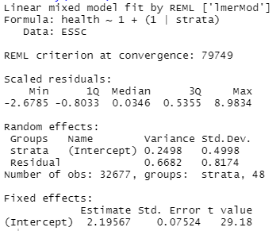

Working from bottom to top of this output, we can see that the mean health score across all strata is 2.20 (the “Intercept” value). The random effects section shows us the variance at each level – 0.25 at the strata level and 0.67 at the individual level. That means that about 27% - 0.25/(0.25+0.67) – of the variance in subjective health can be explained by the strata-level differences, whilst 73% of the variance occurs within-strata, between individuals.

Now, we can including the strata-defining variables in the fixed part of the model.

model2 <- lmer(health ~ eth2+gndr+educ3+agecat+ (1|strata), data=ESSc)
summary(model2)

It’s best at this point to compare these models side-by side. I’m going to do that using the tab_model function (in sjPlot package) to make a nice table.

tab_model(model1, model2, digits=3, digits.re=3)

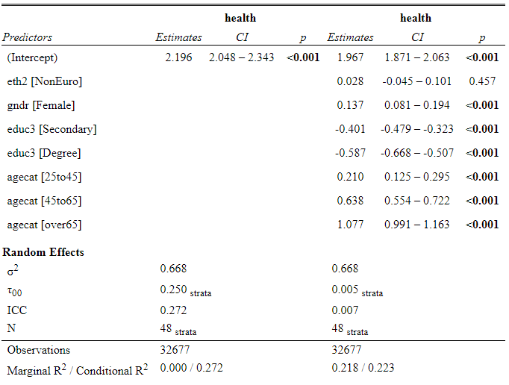

In model 2, we can see that all the variables are statistically significant predictors of subjective health, except for the ethnicity variable. This may be in part because we mushed all non-Europeans together, so in this case it should not be taken to mean that there is no ethnic inequalities in health! Otherwise, women generally have a higher score (so worse subjective health) than men. Better educated, and younger people, are generally more healthy.

Looking at the random part of the model, we can see that the level 1 variance (σ²) hasn’t changed between the two models. We’d expect this as all the variables included only vary at level 2. However the level 2 variance (τ₀₀) has radically reduced. We can calculate how much it has reduced:

(0.250-0.005)/(0.250)

It has reduced by 98% - i.e. only 2% of the variance between strata is not explained by the additive variable; only 2% of the variance is multiplicative.

The question, now, is whether that remaining multiplicative variance is significant. If it isn’t, it would make sense to simplify the model to a single level model, since there is no significant additional variance at level 2. To judge this, we need to run the same model as a single level model, using the lm function

model3 <- lm(health ~ eth2+gndr+educ3+agecat, data=ESSc)

We can then compare the model fit of these two models

anova(model2, model3)

This gives us a number of model fit statistics, including AIC, BIC and likelihood ratio test. For AIC and BIC, low values indicate a better fitting model given the level of complexity of each model. In each case, the multilevel model seems to be a better-fitting model, and significantly so according to the likelihood ratio test. As such, although there is only 2% of multiplicative variance, that small amount of variance is statistically significant.

It would now be useful to plot our residuals, from both these models, to identify which intersectional strata have particularly high/low levels of self-rated health. To do this we will use the REsim command, to produce residuals, and associated confidence intervals, which we can then plot with the plotREsim command. First, we will create a new dataframe with the residuals and uncertainty in them

reEX <- REsim(model1)

Then we will plot these residuals in a “caterpillar plot”

plotREsim(reEX, labs=T) + coord_flip()

The last bit of code turns the graph 90 degrees – useful in this case to make the labels more readable. The result is a ggplot object.

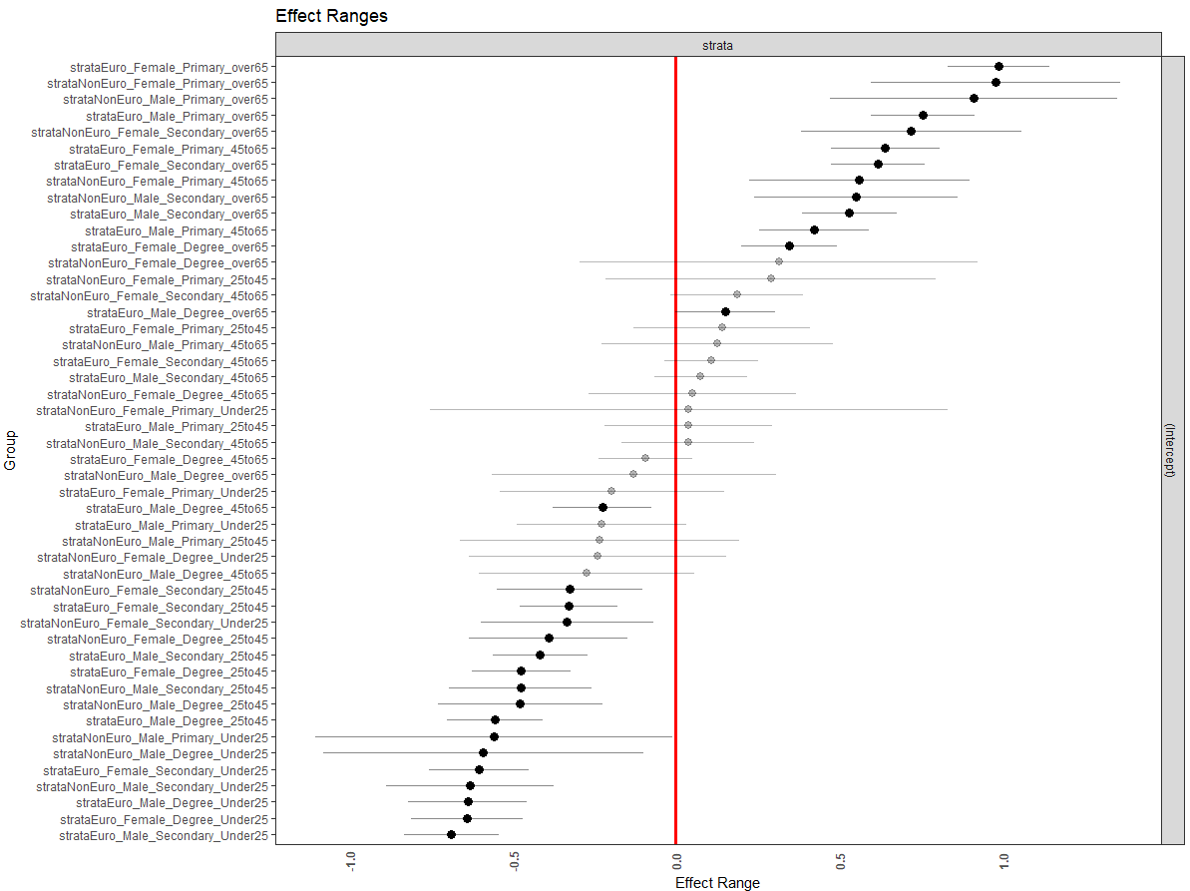

Some test questions:
- Which strata is the most subjectively healthy? Which is the most unhealthy?
- Near the middle you will see a strata with a very large confidence interval. Can you explain why it’s so large? And why it’s so close to the middle?

These are the absolute differences between the strata, but being from model 1, this includes the additive differences. We might also want to plot only the multiplicative differences

reEX2 <- REsim(model2)
plotREsim(reEX2, labs=T) + coord_flip()

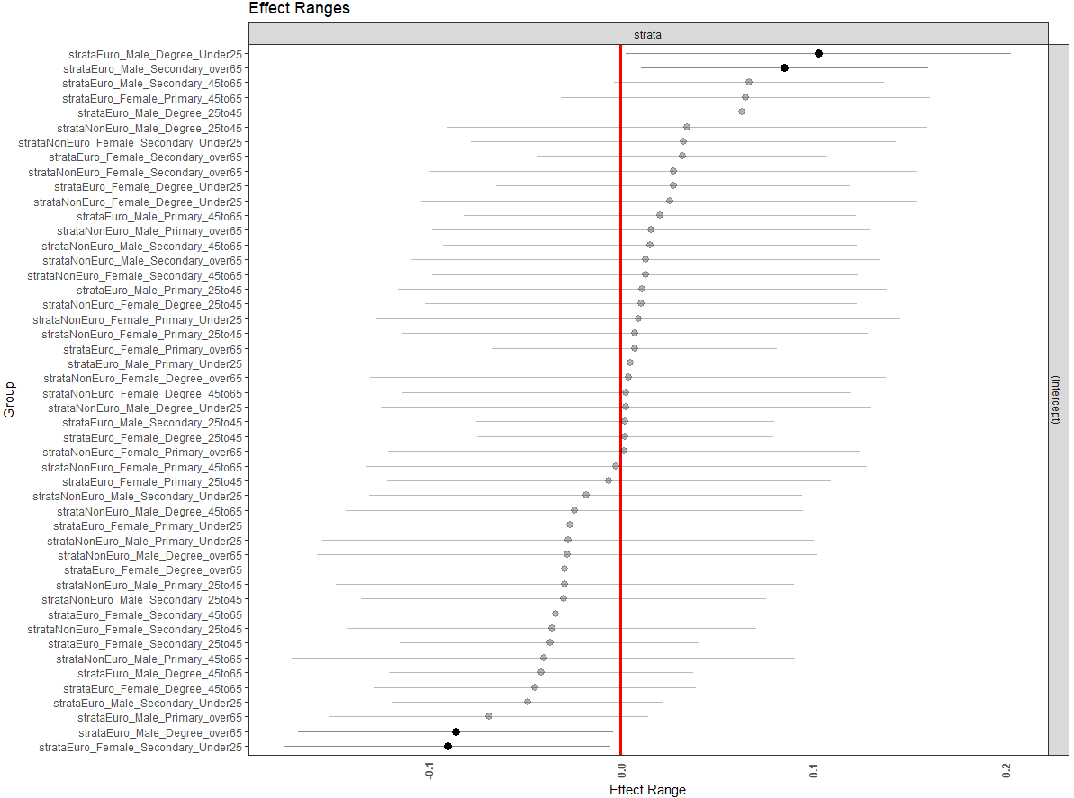

Here we can see much less going on – as we might expect given the small amount of remaining variance once additive effects have been accounted for. But there are a few strata which are showing some statistical significance. For instance, young European men with degrees seem a bit more unhealthy than we would expect given the main effects of the strata-defining variables. Older European men with degrees seem to be slightly more healthy than we’d expect given the additive effects of the strata-defining variables.

In the above plots, we have ordered the variables by their rank – with positive residuals at the top and negative residuals at the bottom. However, we might choose to order by the variables instead, as this can help to understand specifically what is happening. For instance, we could order the strata by Age, then Gender, then Education, then Ethnicity (for now with the model 1 residuals).

First, we need to create those separate strata-defining variables in our reEX dataframe. We can do this using our strata identifier (the variable “groupID” in reEX), splitting by “_” (which we chose as a separator when we created the strata variable originally with the paste command).

variables <- colsplit(reEX$groupID, "_",
names=c("Ethnicity", "Gender", "Education", "Age"))

This creates a new dataframe, that we then need to merge back into reEX, first by creating an identifier for our two dataframes, and then merging using those identifiers.

variables$obs <- seq.int(nrow(variables))
reEX$obs <- seq.int(nrow(reEX))
reEX <- merge(reEX, variables, by="obs")

We then want to sort by our variables, but first we want to make sure the order of those variables (particularly education and age) is correct

orderEd <- c("Primary", "Secondary", "Degree")
orderAge <- c("Under25", "25to45", "45to65", "over65")
reEX$Education <- factor(reEX$Education, levels=orderEd)
reEX$Age <- factor(reEX$Age, levels=orderAge)

We can then sort our dataframe

reEX <- reEX[order(reEX$Age,reEX$Gender,reEX$Education,reEX$Ethnicity),]

Then create a new “rank” variable that defines the order that the variables should be on our graph.

reEX$newrank <- seq.int(nrow(reEX))

We then turn that rank into a factor variable with the correct labels.

reEX$newrank <- factor(reEX$newrank, labels=reEX$groupID)

Because plotREsim produces a ggplot object, it can be adapted in the same was as any other ggplot object

plotREsim(reEX, labs=T) + coord_flip() + aes(x=newrank)

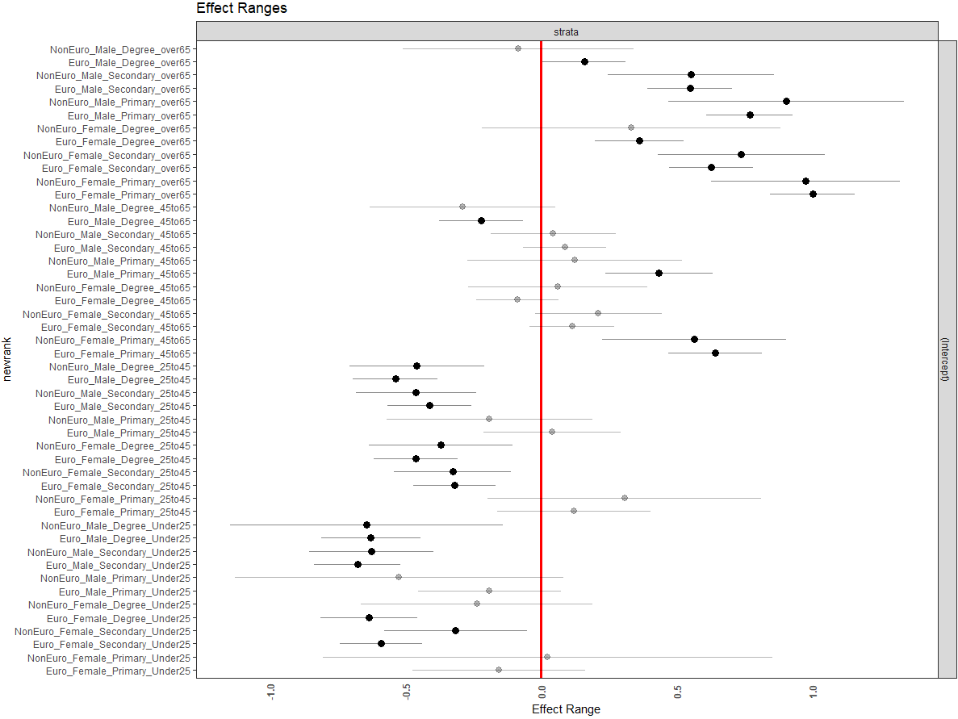

This graph makes much clearer the age trajectory, because we sorted by that variable first. But we can also see the education and gender gradients within the age category.

Congratulations – you’ve reached the end of the practical exercise! It is an imperfect example (given the non-ideal ethnicity categorisation, and the non-Normality of the dependent variable) but hopefully gives you an idea of how these models can be run in R and interpreted.

A few things to try if you want to play with these models further
- Try making the above graph, but with different variables being ordered. How does it change the story that is being told?
- Given the dependent variable is a categorical variable, you could (a) categorise it into 2 groups, and (b) run it as a linear probability model or a logit model
- What happens if you use different categories? Eg try running the model with the 8-category ethnicity variable instead. What are the advantages / disadvantages of each approach?

